Survey & Plan

Traffic Sign Recognition

# Team Introduction:

**Team 5** - Our team has 3 members:

* **Pham Thi Thu Hien** – 2022120203 (Ultra-intelligent Computing / Communication Network Lab).
* **Tran Nam Phuong** – 2022120207 (Ultra-intelligent Computing / Communication Network Lab).
* **Nguyen Lan Anh** – 2022220111 (Systems and Storage Lab).

# Project Overview:

Traffic sign recognition can be an extremely useful assistance tool for drivers. For example, the system notifies the driver when a speed limit sign or other traffic sign is detected, keeping the driver informed of speed limit changes and other important road information. That is the reason why this topic is very practical and will nerver get old, expecially when automated driving and driverless cars are emerging nowadays.

# With this in mind, we will propose a solution to tackle the traffic sign recognition problem by utilizing the Convolution Neural Network (CNN) built on the base of TensorFlow. By doing hands-on work, we hope we will be able to learn about several image processing techniques and also improve our teamwork skills. In this document, we will provide some surveys about the traffic sign recognition topic, as well as propose a plan for our project.

# Standards:

* Coding language: Python.
* IDE: Visual Studio 2019.
* Source code management: GitHub [4].

# Objectives:

* System must be able to classify an input image to a proper traffic sign.
* Acceptable accuracy is >= 85%

# Requirements/Task(s):

* Task 1: Data preporcessing

1. Data visualization.
2. Image processing: Resize, noise removal, geometric correction, etc.

* Task 2: Model building

1. Feature extraction
2. Model building
3. Model training
4. Model testing

* Task 3: Post process (improve the model performance).
* Task 4: Writing final report.

# A brief survey:

This is a brief survey about traffic sign recognition topic.

1. Data set.

There are a few data sets being open to public, which were metioned in [1] as follows:

* German TSR Benchmark (GTSRB)
* KUL Belgium Traffic Signs Data set (KUL Data set)
* Swedish Traffic Signs Data set (STS Data set)
* RUG Traffic Sign Image Database (RUG Data set)
* Stereopolis Database

Compared to other data sets, the GTSRB is most frequently utilized in various research. This is a large data set and was originally created for the “German Traffic Sign Recognition Benchmark.” [2]. This data set is mainly used for classification purposes since each image contains exactly one sign without much background.

In this project, we are going to use this data set to address the traffic sign recognition problem. This data set can be found in the Kaggle platform [3]. Here are some images from the data set.

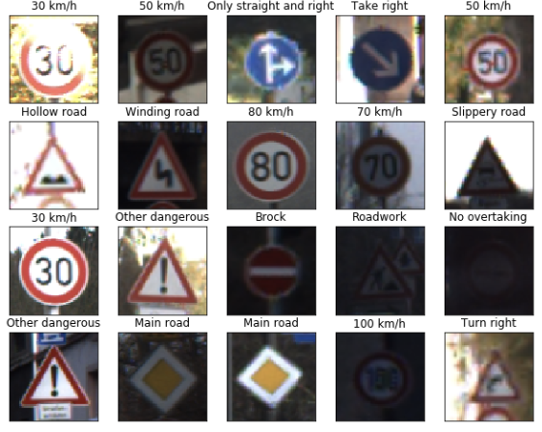

1. Methodology.

The flow of a typical traffic sign recognition solution often goes as follows:

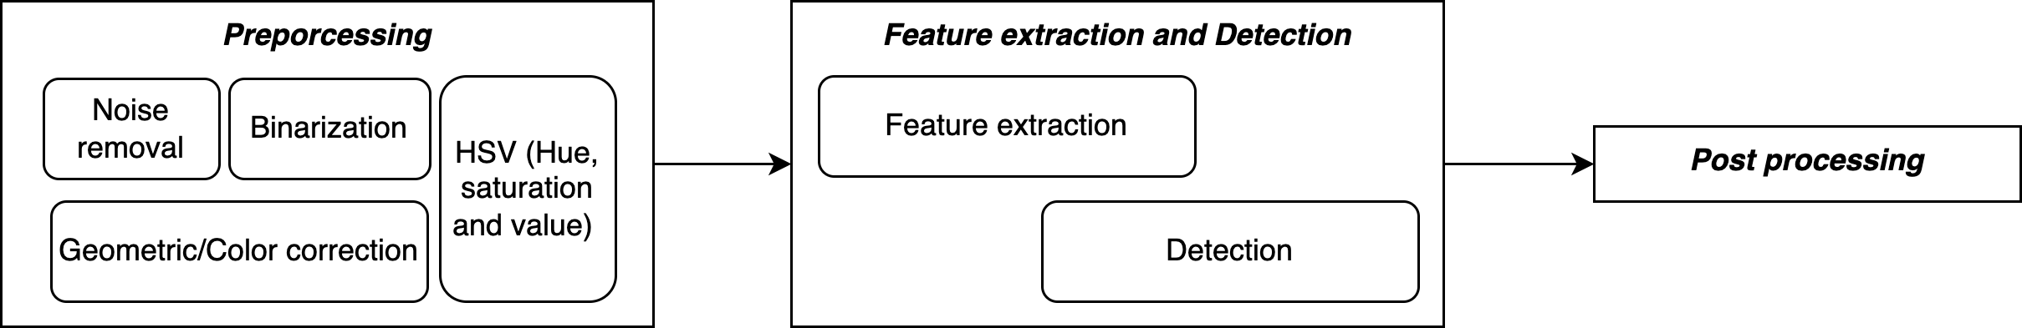

* Preprocessing: This step is typically done to correct the original images to be ready for the model input. There are several image processing techniques could be used in this process. Some of them are Noise removal, Binarization, Geometric/Color correction, HSV (Hue, saturation, and value), etc.
* Feature extraction and Detection: This step is to isolate and detect various local patterns of an image. Some of the famous models can be used for the detection process such as Support Vector Machine (SVM), Convolution Neural Networks (CNN), Deep Neural Networks (DNN), etc.
* Post-processing: This process is for improving the efficiency of detection.

1. Challenges.

* Many images are taken by hand and moving devices, leading to motion blur in the image itself. A proper preprocess should be performed to tackle this problem.
* Since the data is media type, it could result in the issue of computational overhead. The model should be not only efficient but also lightweight.

# Plan for the project:

According to the normal flow, we have a time schedule as follows:

# 

# References

[1] Mogelmose, Andreas, Mohan Manubhai Trivedi, and Thomas B. Moeslund. "Vision-based traffic sign detection and analysis for intelligent driver assistance systems: Perspectives and survey." *IEEE Transactions on Intelligent Transportation Systems* 13.4 (2012): 1484-1497.

[2] J. Stallkamp, M. Schlipsing, J. Salmen, and C. Igel, “The german traffic sign recognition benchmark: A multi-class classification competition,” in *Proc. IJCNN*, 2011, pp. 1453–1460. [Online]. Available: <http://benchmark.ini.rub.de/?section=gtsrb>

[3] <https://www.kaggle.com/datasets/meowmeowmeowmeowmeow/gtsrb-german-traffic-sign>

[4] <https://github.com/phuongtrannam/advanced-image-processing-cau>